10.1.12 Editors - Geometry Nodes Editor - Header - Add Menu - Volume
Detailed table of content 1
Add menu - Geometry 1
Join Geometry 1
Transform 2

Detailed table of content
Detailed table of content
Detailed table of content 1
Add menu - Geometry 1
Join Geometry 1
Inputs 2
Geometry 2
Output 2
Geometry 2
Transform 2
Inputs 2
Geometry 2
Translation 2
Rotation 2
Scale 2
Output 2
Geometry 2

Add menu - Volume
Here you find nodes to modify the volume.

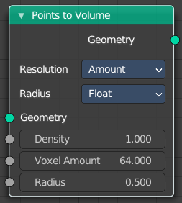
Points to Volume
Converts a point geometry to a volume.

Inputs

Geometry
Standard geometry input.

Density
The density of the point cloud.

Voxel Amount
The voxel amount to use.

Radius
The input radius.

Properties

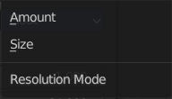
Resolution
Base the voxel resolution at the amount or the size of the point cloud.

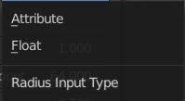
Radius
Not documented yet.

Output

Geometry
Standard geometry output.

